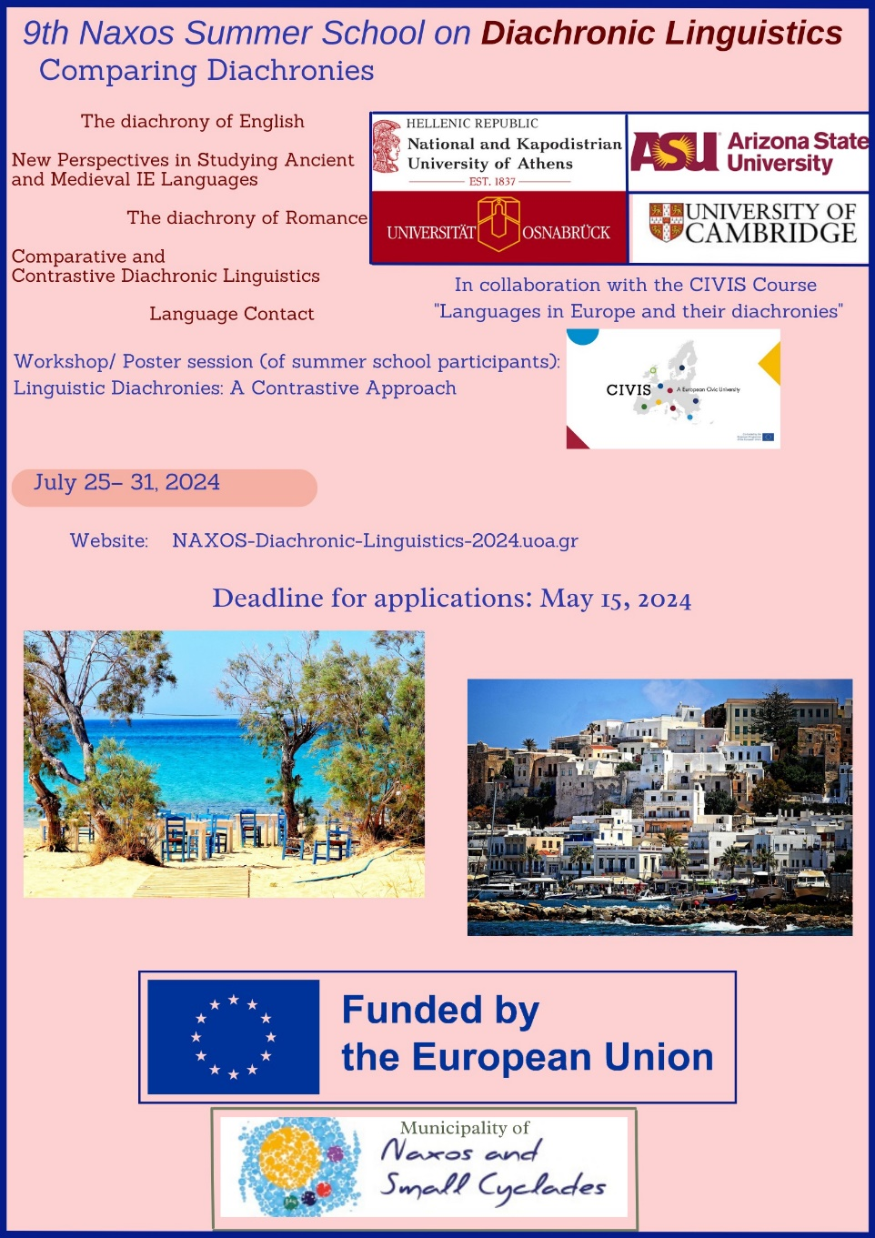
9th Naxos Summer School on Diachronic Linguistics. Comparing
Diachronies

Host Institution: National and Kapodistrian University of Athens
Website: http://naxos-diachronic-linguistics-2024.uoa.gr/

Dates: 25-Jul-2024 - 31-Jul-2024
Location: Naxos, Cyclades

Focus: Intensive language classes on ancient and medieval languages
and linguistic classes on the diachrony of languages – Comparing
Diachronies
Minimum Education Level: BA

Description:
Host Institution: National and Kapodistrian University of Athens
Coordinating Institutions: University of Athens, Arizona State
University, University of Osnabrück, University of Cambridge, CIVIS
Course “Languages in Europe and their Diachronies”

Apply here: https://forms.gle/mCvk4j9MGJVrrbA47

We are happy to inform you that registration is now open for the 9th
Naxos Summer School on Diachronic Linguistics.

National and Kapodistrian University of Athens, Arizona State
University, University of Osnabrück and University of Cambridge
collaborate with the CIVIS Course “Languages in Europe and their
Diachronies” and coordinate a summer school program, a workshop/
poster session and master classes on ancient and medieval languages
and linguistics, to be held on July 25 - 31, 2024 on the island of
Naxos, Greece.

The summer school will offer intensive language classes and linguistic
classes on Diachronic Linguistics. The aim is to attract students and
scholars to study ancient and medieval languages in a relaxed yet very
focused and stimulating atmosphere that promotes in depth analysis and
discussion.

Students will be able to earn up to 6 ECTS from the summer school.

The 9th Naxos Summer School on Diachronic Linguistics will also be
organizing a workshop/ poster session on “Linguistic Diachronies: A
Contrastive Approach”.

Registration fees: 200 euros (it covers light lunches, too)

Applications accepted until 15-May-2024 3 scholarships available
(that cover the registration fees) for university (BA, MA, PhD)
students.
In order to apply for a scholarship, please email your motivation and
your CV to nlavidas@enl.uoa.gr [Nikolaos Lavidas] before May 15, 2024.

Contact Person: Nikolaos Lavidas
Email: nlavidas@enl.uoa.gr

