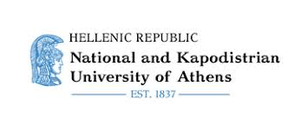

**3rd Postgraduate Workshop in Pragmatics**

Department of English Language & Literature

National and Kapodistrian University, Athens

June 24-25, 2025

**Announcement**

*In the recent years, the study of meaning and human communication has become more and more interdisciplinary, combining linguistic pragmatics with insights from cognitive and affective science, psycho- and neurolinguistics, L1 and L2 acquisition, stylistics, audio-visual translation, and many more areas. This two-day Workshop aims to offer a venue to PhD students, as well as to early postdoctoral researchers, for presenting their research on any topic related to pragmatics.*

This workshop welcomes in priority submissions from PhD students of participating departments and researchers. Other submissions might be considered depending on available time slots.

**Invited speakers**

Prof. Victoria Escandell-Vidal, *Universidad Complutense de Madrid*

Prof. Didier Maillat, *Université de Fribourg*

PhD students and post-docs who wish to present a 20-minutes paper at the Workshop are invited to submit a 250-word Abstract and a brief bionote on:

[https://pragmathens3.sciencesconf.org](https://pragmathens3.sciencesconf.org/)

Abstracts should be in Times New Roman 12 pt, single spaced. References should be in APA 7th edition. The deadline for Abstract submissions has been extended until **February 15, 2025.**

**Important dates**

Deadline for Abstract submission: January 31st, 2025

Notification of acceptance: March 15th, 2025

Workshop: June 24th-25th, 2025

**Venue**

Library Amphitheater, School of Philosophy (Zografou campus), Athens, Greece

**Registration**: free

**Workshop organizers**

Elly Ifantidou (NKUA)

Louis de Saussure (Universitéde Neuchâtel)

Anna Piata (NKUA)