Author Paul Auster interviewed by George Giannakopoulos,
Ph.D. Candidate in the Faculty of English Language and Literature,
at the Stegi Grammaton kai Technon of the Onassis Foundation, Athens,
on November 6, 2014
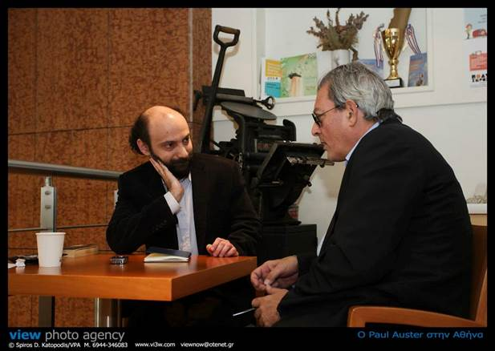
Q: Studying your work, I have observed a persistent concern throughout its corpus for loss in connection to writing, not only as a theme of your writing but also as the very condition of writing and the position of the author. Is loss another name for writing, or, to put it in slightly different terms, is your literary work, for you, a way to perform what in psychoanalysis is called mourning work?
A: I would say that there is something to what you’re saying, but it’s not only that. It’s certainly something that comes up in my work fairly often. This is the hardest thing we have to do as human beings. To cope with the disappearance of people we care about. I don’t think there’s anything more difficult emotionally. So, in many of my books the protagonist has lost somebody or something and has to figure out a way to go on. But it’s interesting that none of my characters is suicidal. They really want to live. They really want to live but they just don’t know how. Many of my books are about the journey of their trying to figure out how—in one way or another. The mystery about language is, as I wrote when I was very very young, language gives us the world but it also takes it away from us at the same time. Because there is always a feeling, and every writer would say this, that what you’re saying is only approximate. You never can say the things that really need to be said because the things that need to be said are somehow not compatible with language. Language is such an approximate tool, we need it, without it we wouldn’t have the world, but, you know, we’re looking at this table—I could have explored this in City of Glass with crazy Stillman Senior—so here’s how it would be. We have the word “table” and this is a category that enables us to isolate a table from chairs or coffee cups. But, when you start looking at this table—this happens to be a square table made out of wood but there are circular tables made out of metal and there are triangular tables made out of other materials, and yet we call them all tables. Stillman’s idea is that, well, each different kind of table needs a different word, and then, finally, every object in the world needs a different word, which, in effect, destroys language. Language forms categories and helps us perceive things and distinguish them, and it is a crazy notion that somehow we would be capable of expressing the individuality of objects and still understand, but we would be lost in a chaos. But for him it would be a kind of new prelapsarian language.
Q: You read yesterday the last paragraph from Winter Journal where you describe your father visiting you in your dreams. There is a dark room and a table, and you both sit there talking. Is this room—I’m trying to bridge a gap of about thirty years—somehow connected to the rooms of The New York Trilogy, Peter Stillman’s room, the locked room, Blue’s room?
A: It’s possible. You’re going way back when I was much younger and I was focusing my energies mostly on poetry. The first manuscripts, the first poems, that I thought had something to them but I never published them, early works that I left behind within six months. But that little book was called Captives and the poems really were about people who were captives. It’s something I’ve been thinking about forever. But I don’t know why. I think that part of it might be an experience I had in Paris that I write about in The Invention of Solitude with my Russian composer friend. He lived in a space so small but he had everything he needed there. He could barely move but he was somehow self-sufficient in that penthouse. The room is a mind and then inside… no. The room is a body, the room is a small body and the body that is the man inside the room is a mind. It is a strange Aristotelian formation. So I think I have to be psychoanalyzed in order to understand this obsession with enclosures. Somebody wrote, and I find great interest in it, a Frenchman called Pascal Bruckner—do you know who this is?—back in the day when my French publisher did a paperback of—I think it was—The Invention of Solitude they asked him to write a preface and I thought it was a very intelligent piece of work, very good, very […], and he said something that struck me, he said all my work is a kind of oscillation between confinement and then freedom, openness. And he said that the paradox is that people are freer when they’re confined than when they’re free to wonder around. And I think there is some truth in that.
Q: Confinement is associated with writing…
A: Yes, I think so. And thought.
Q: In The Invention of Solitude there is a wordplay between room, womb, and tomb. Is the room a feminized or female space occupied by a male writer—there is a kind of a polarity of this sort in your early work—not so much in your later novels, right?
A: No, although you know, there are these two books which now I thought of them as a pair and now I managed to publish together, it’s Travels in the Scriptorium and Man in the Dark. And I have an overall title for them, it’s Day/Night: Two Novels. Because the situation is the same, it’s an old man alone in a room. The first one takes place during the course of one day, the other one in the course of one night. Of course the situations are different, the men are different. In the first one, Mr. Blank is very confused, he can’t remember anything. For me it’s a book about old age and how people lose their memories […] they barely know what’s going on, they don’t understand the continuity of time, everything seems to be happening suddenly and […]. The other one is much more lucid and younger. He’s […] but he’s not demented in any way. He’s making up dark and imaginary stories to adapt to insomnia. […] I haven’t put anyone in a room in that way anymore. Maybe I’m done with the room. I don’t know. I don’t know.

